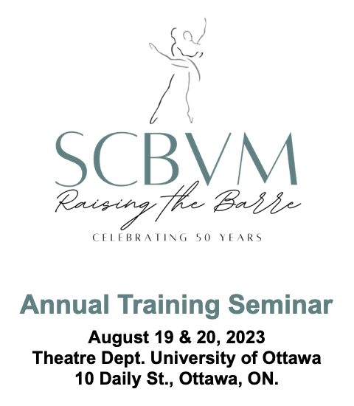

Registration & Seminar Inquiries: Contact operations@scbvm.org.
To register: Remit a completed form with payment to info@scbvm.org no later than Aug. 5, 2023.

NAME: _______________________________ STUDIO: ___________________________________

EMAIL: _________________________________________ PHONE: _________________________

I am a (tick one): Member ______ Student Teacher-in-Training ______

Non-Member ______ Dancer (Master Class Registrant) ______

EARLY BIRD DISCOUNTS:
To receive the early bird discount, pay your seminar registration fee by June 15, 2023.

REFERRAL REWARDS:
- Refer non-members to our Seminar and receive 50% of the value of their seminar registration fee as a credit on your account for 2023/24.
- Members must fill out the information below to receive their reward.
- Referrals must have paid their seminar fees in full prior to awarding any rewards to members.
- Members may receive more than one reward. Please send a separate registration form for each referral.
- The value of Referral Rewards will be credited to the Member’s account on September 1, 2023.
- Referral Rewards may not be redeemed for cash.

REFERRAL REWARDS INFORMATION:
I have referred the SCBVM & Raising the Barre to the following non-member:

NAME: _______________________________ STUDIO: ___________________________________

EMAIL: _________________________________________ PHONE: _________________________

AWARDS NIGHT ONLY TICKET:
If you would like to attend our Awards Night event but are unable to participate in the full seminar tickets are
available for $35.00 (tax included) per person. Please complete the contact information at the top of this form
and specify how many tickets you would like below.

I would like ______________ (specify number) of Awards Night Only tickets.

T-SHIRT PRE-ORDER:
SCBVM 50th Anniversary t-shirts are available for pre-order. Please indicate the size you would like reserved and include your payment in the chart below. Image available for viewing on the website seminar page.
Please reserve the following size (tick one): Small ___ Medium ___ Large ___ X-Large ___

FEES:

Membership Level | Seminar Fee | Early Bird Discount | Fee to Remit
 | due Aug. 5, 2023 | Due June 15, 2023
Member | $300.00 | $275.00
Student Teacher-in-Training | $125.00 | $110.00
Non-Member | $400.00 | $375.00
Dancer (Master Class Fee) | $35.00 | n/a
Awards Night Only ticket | $30.97/per person | n/a
T-Shirt | $20.00 | n/a
 |  | Sub-Total:
 |  | add 13% HST:
 |  | Total Fees:

PAYMENT INFORMATION (tick method of payment):

_____ Credit Card Number: ____________________________________________ Expiry: _______/_______

Name on Card: ________________________________________________

_____ I will remit an e-transfer to info@scbvm.org.

_____ I will send a cheque payable to the Society of Classical Ballet (Vaganova Method). See address below.

P.O. Box 13046, 140 Holland Street W., Bradford, ON, L3Z 2Y5
289-231-9304 • www.scbvm.org • info@scbvm.org

P.O. Box 13046, 140 Holland Street W., Bradford, ON, L3Z 2Y5
289-231-9304 • www.scbvm.org • info@scbvm.org

